**Ideation Phase**

**Brainstorm & Idea Prioritization Template**

|  |  |
| --- | --- |
| Date | 19 july 2025 |
| Team ID | LTVIP2025TMID41526 |
| Project Name | Revolutionizing liver care: predicting liver cirrhosis using advanced machine learning techniques |
| Maximum Marks | 4 Marks |

**Brainstorm & Idea Prioritization Template:**

Brainstorming helps us generate innovative solutions by combining medical insights with technological possibilities. In this project, our goal is to develop a machine learning model that accurately predicts liver cirrhosis at an early stage, empowering patients and healthcare professionals alike.

This template enables our team to collaborate creatively—whether in person or remotely—to explore a wide range of ideas across data collection, feature selection, user experience, model accuracy, clinical relevance, and ethical concerns like patient privacy.

By encouraging open discussion, we can prioritize impactful ideas such as:

* Non-invasive data collection methods
* Features most relevant to early cirrhosis detection
* Patient-friendly interfaces and report generation
* Clinical integration and real-world usability
* Awareness tools and feedback loops

Using this structure, we ensure that our most valuable and feasible ideas are recognized, refined, and implemented—ultimately leading to a predictive tool that not only works, but truly serves the people who need it.

This brainstorming session is focused on identifying ways to **improve the lives of patients** at risk of liver cirrhosis. By encouraging all voices—technical, clinical, and user experience—we can generate a wide variety of ideas, from better symptom tracking methods to enhanced patient communication tools. Using this template, we'll prioritize those ideas that not only improve model performance, but also increase **trust, accessibility, and early intervention** in liver care.

**Step-1: Team Gathering, Collaboration and Select the Problem Statement**

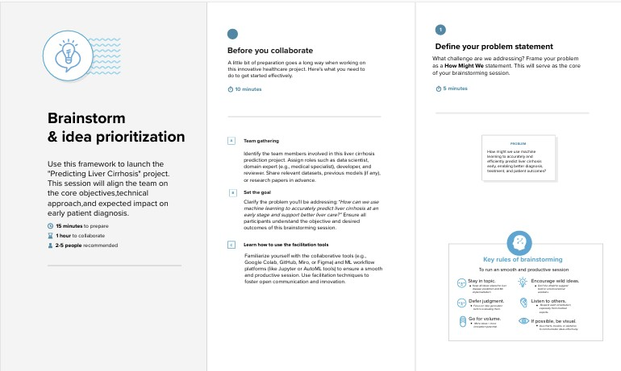

# Step-2: Brainstorm, Idea Listing and Grouping

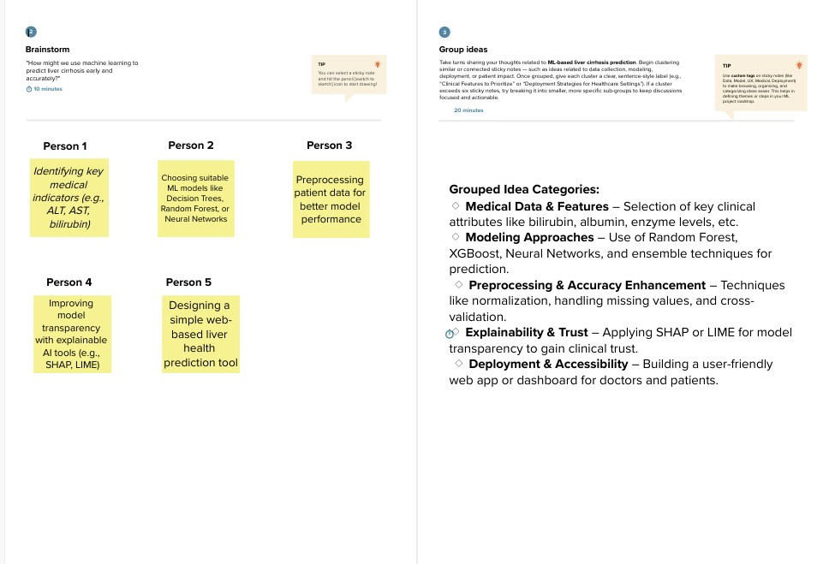

# Step-3: Idea Prioritization

